**In this video, We would learn about what is flow chart & what is pseudocode. What is use of programming amd why to do programming?**

* **FlowChart:** It is visual representation of program using diagrams and shapes having a fixed meaning.  
  Example : In a flow chart the **Eclipse** denotes the starting and end of the program.  
  **Parallelogram** denotes the input or output statement.  
  **Rectangle** denotes the calculation or some arthimatic operations.  
  **Rhombus** denotes the decision or comparison, etc.  
  **Note : There is no symbol or shape for loops but decision shape can be used to make loop.**

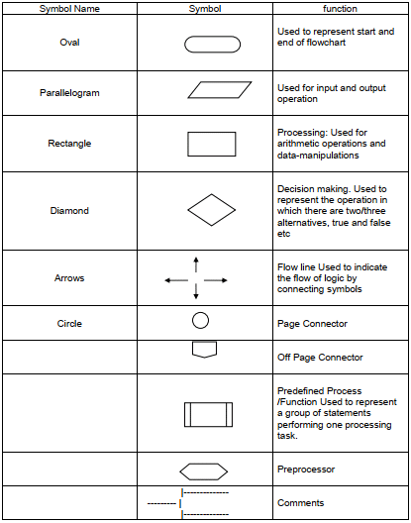

* **PseudoCode:**It is general instructions without any syntax but once it is written it can be easily converted into a code.
* **Programming Languages**are special lamguages which can be conberted into computer understandable format which is written in a fix format known as syntax.
* We know that a computer can perform calculations and other action better than human beings but we can't give instuctions directly to computer as it only understand 0 and 1. so we write a program in a human understandable format and then a program convert it into the computer understandable program this program is known as compiler.